Training a CNN in Edge Impulse

Introduction
Now that we have covered how convolutional neural networks (CNNs) work, let’s train one! We’re going to use the same dataset from the first module to train a CNN model on Edge Impulse rather than a simple dense neural network.
You are welcome to use my electronic components dataset if you did not collect your own.

Convert Images
At this time, Edge Impulse only accepts .png and .jpg images. If you originally collected your dataset as .bmp files, you will need to convert them to one of those two categories. I recommend .png, as it is a lossless format.
- Windows: use something like Bulk Image Converter
- Mac: use the built-in tools or something like XnConvert
- Linux: ImageMagick has some good command line tools for converting images
Or if you’re feeling particularly enthusiastic, you could write a quick Python script (using something like PIL) to get the job done.
I recommend keeping the directory structure the same so that you can determine the label of each sample by just looking at the name of the containing folder.

Upload Dataset
The good news is that we can upload image data directly to Edge Impulse rather than having to manually extract features using Colab.
Start a new Edge Impulse project. Go to Data acquisition. Click the button to Upload existing data. Click Choose Files and select all images for one class (e.g. resistor class). Leave Automatically split between training and testing selected. For Label, enter a label for your first category (e.g. “resistor”).
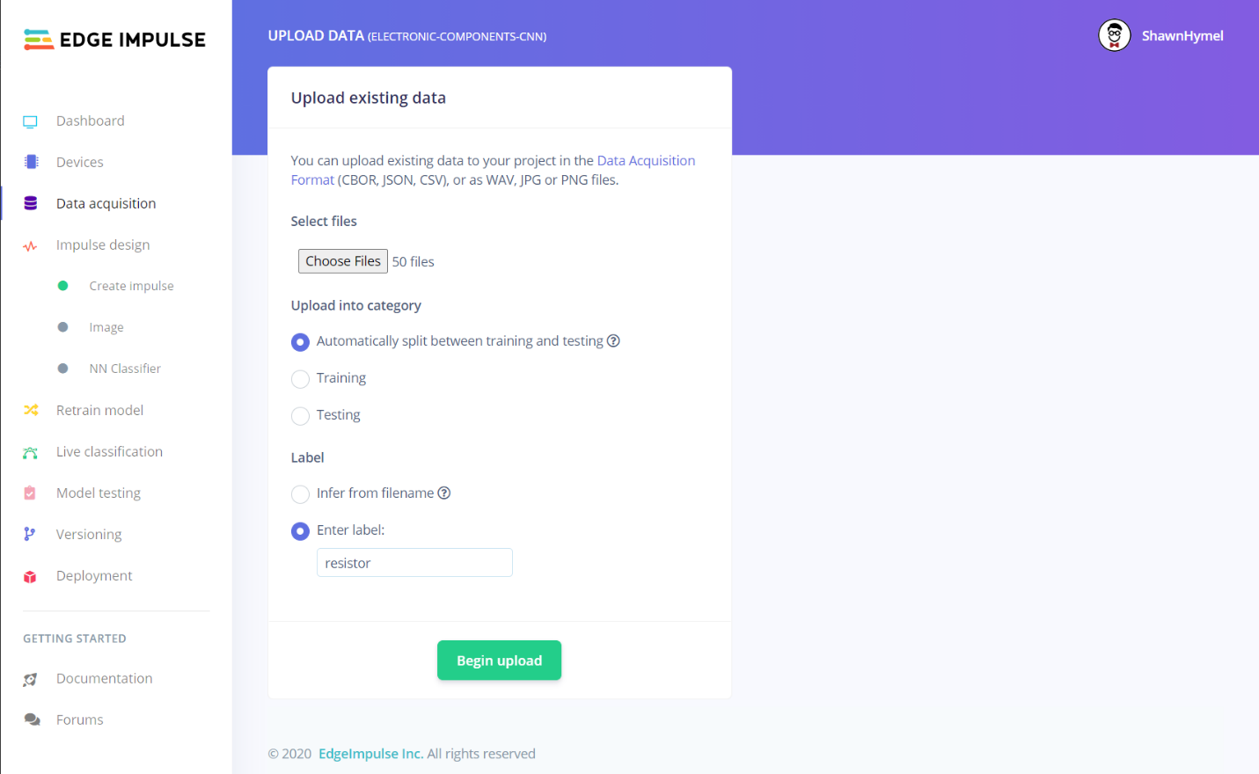
Click Begin upload. Repeat this process for the rest of the categories in your dataset. When you are done, go to Data acquisition. Make sure that you have a good representation of samples in your training and test sets.
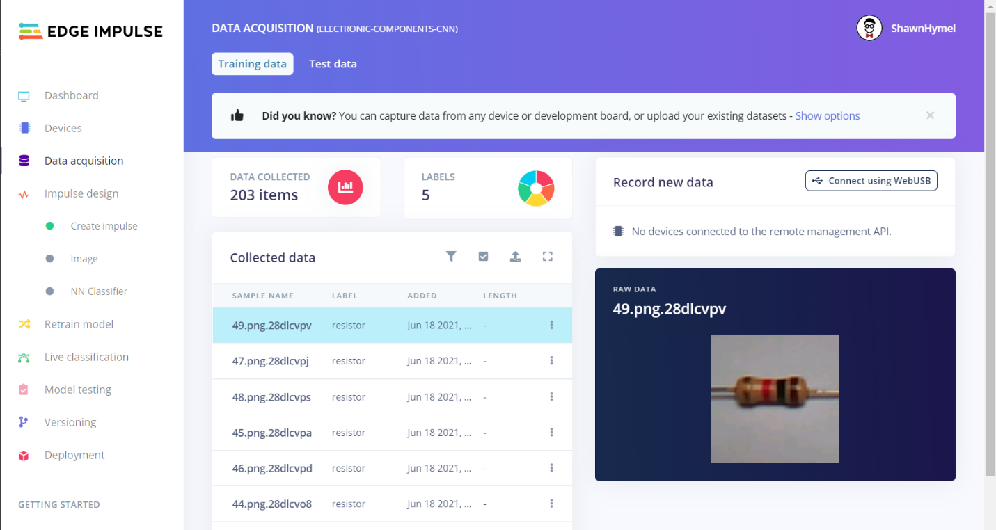

Create Impulse
Head to Impulse design. Change the Image data setting to 28 x 28 (width x height). If your original images are not all square, you can adjust the Resize mode as needed to crop or squish the images.
Add an Image processing block. Add a Classification (Keras) learning block.
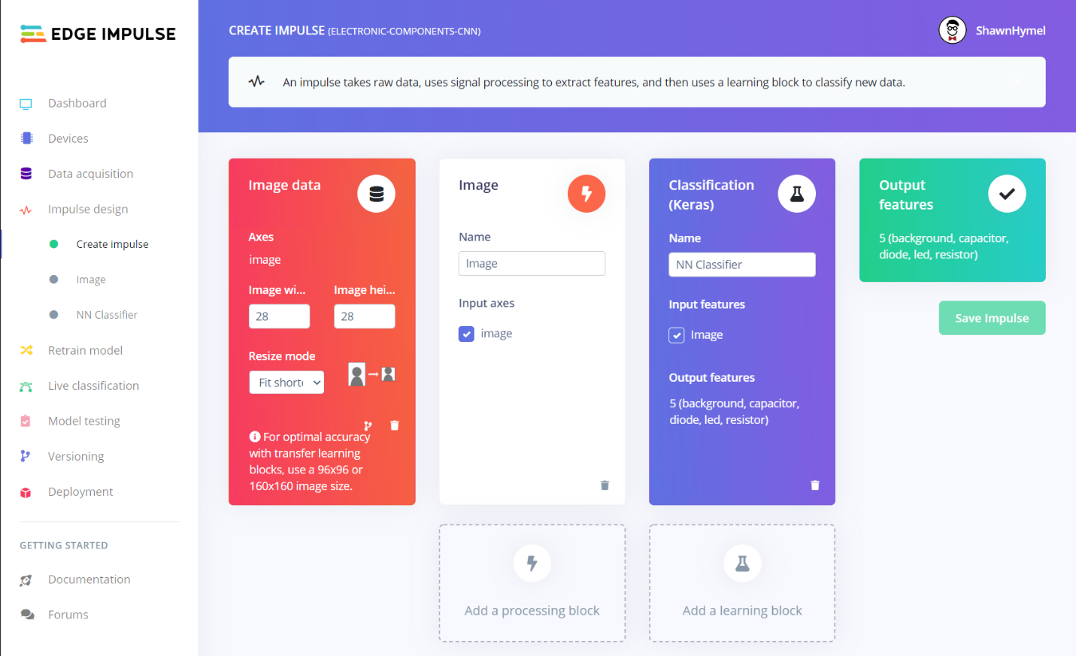
Click Save Impulse.

Extract Features
Go to Image under Impulse design on the left-side navigation bar. Change Color depth to Grayscale. Click Save parameters.
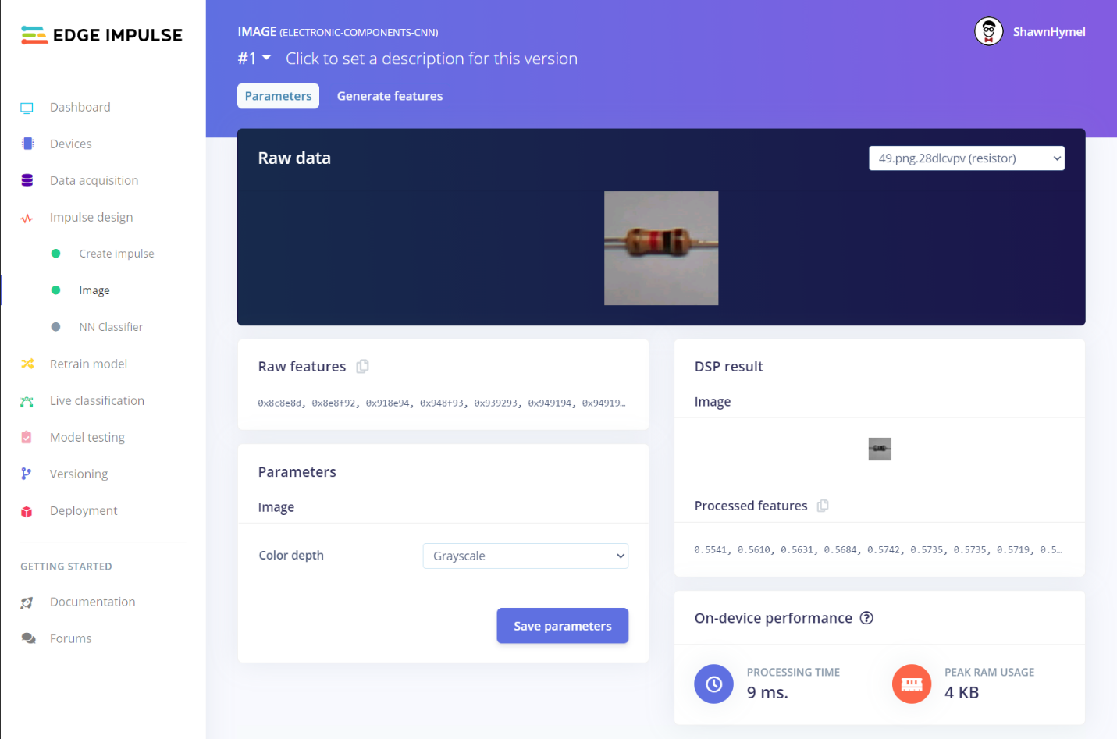
On the next screen, click Generate features. Wait until the feature generation script is complete. Here, images are being converted to grayscale and 28x28 pixels.
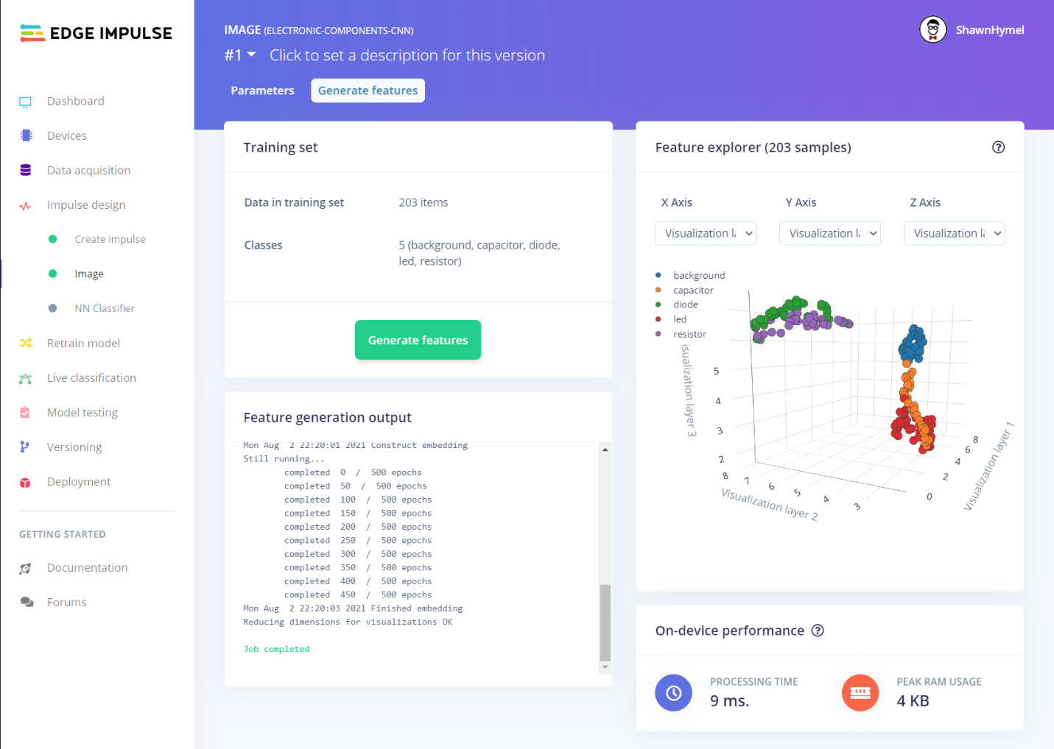

Train!
Go to NN Classifier. I recommend changing the Number of training cycles to something between 100 and 200 (as we are working with a small dataset). Click Start training. When training is done, how well did your model perform?
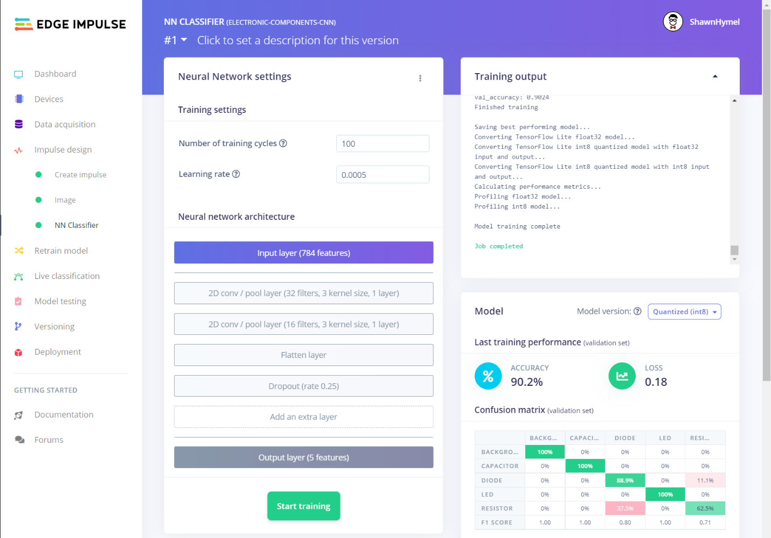
Try adjusting the model hyperparameters, such as number of training cycles, number of filters, and kernel sizes. You can try adding and removing layers. For example, I added a dropout layer after the first convolution layer and changed the second convolution layer to have 28 filters. This seemed to provide a better accuracy on the validation data.
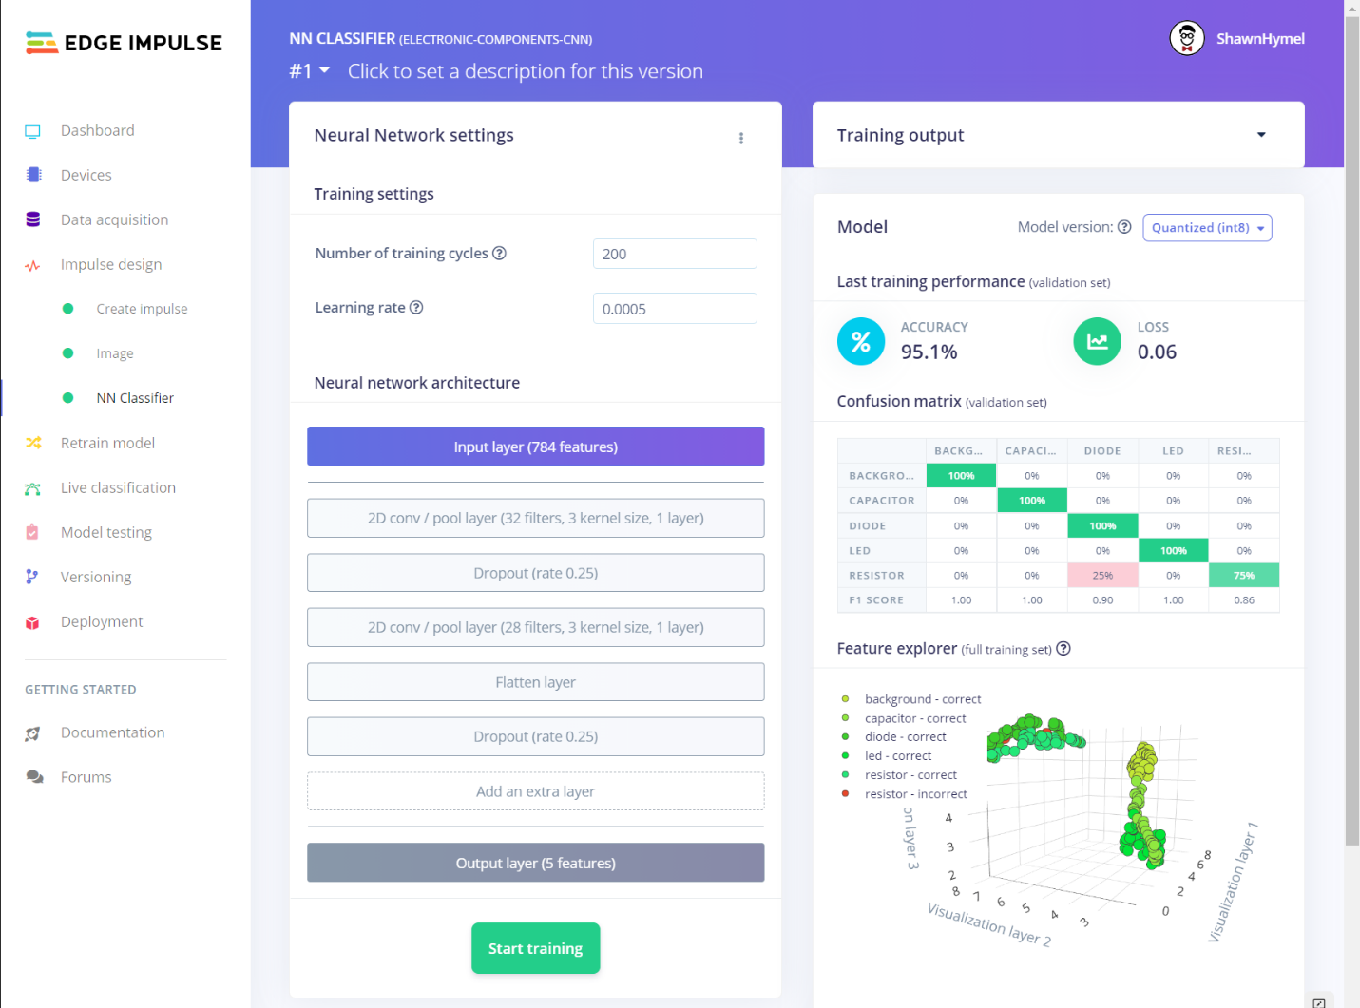

Conclusion
Comparing the accuracy results of this model with those of the dense neural network example might be misleading. Remember that we are working with a relatively small dataset (50 samples per class), and the samples are likely randomly distributed between training and test sets. Moving a single sample in or out of the training set could cause the validation accuracy results to sway by 0.5% (assuming 200 samples in the training set). A larger dataset would help prevent overfitting and give you a much better idea of the model’s viability. We will explore ways to create larger datasets in a future lecture and project.

